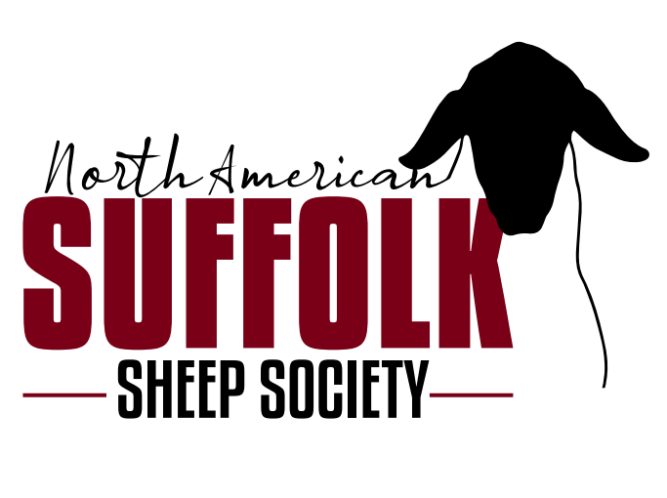

**2024 NASSS Junior Futurity Show**

**Sponsored by the North American Suffolk Sheep Society**

**Mission Statement:** To provide registration services along with promoting and celebrating all facets of the Suffolk Breed.

**2024 NASSS Futurity Rules**

**Point Scoring:**

* A point records form must be filled out for each show and forwarded to the North American Suffolk Sheep Society office within 30 days of the show. The form must be signed by the superintendent of the appropriate show so, it is best to get them filled out while you are still at the show. Scanned and emails of forms are accepted.
* At each individual show the ewe may earn futurity points from both the open division show and/or the junior division show only if the shows are held at different times and judged by different judges. Only the junior show placing from the North American International Livestock Exposition will be counted. Futurity ewes can only be shown in breeding class. The ewe lamb and yearling ewe cannot be shown in market classes.
* One Nationals Regional Junior show will count as double points. If you show at more than one National, Regional show the highest point total will be doubled. It is not required that you show at a National or Regional show.
  + All American -National
  + Midwest Junior Suffolk Show-National
  + Louisville Junior Show (NAILE) -National
  + State Fair
  + County Fairs
* Futurity yearling ewes and ewe lambs may be shown at an unlimited number of shows and submit points from the shows shown in. Only the top 5-point forms submitted can be used toward the futurity final point totals.
* No designated show will be held before May 1st.
* Futurity awards will be announced during the annual meeting of the North American Suffolk Sheep Society. Premiums will be mailed to the winners from the Associated Registry office after December 1st. Winners will also be posted on the North American Suffolk Sheep Society website.
* There will also be separate divisions for bred and owned. An individual sheep can only participate in one division.
* In case of a tie, each animal that is part of the tie will receive the same amount.

**Exhibitor Rules:**

* Rules of exhibition shall be those published in respective premium books of each show.
* All ewe lambs and yearling ewes must be nominated by Sept 1st. A lamb or yearling can be nominated at any time up till September 1st but only show points after the nomination date will be counted.
* All juniors who meet the requirements for the Junior Show at the North American Livestock Exhibition are eligible to participate in the Futurity Ewe Lamb and Yearling Ewe program. Rules for the NAILE are:
  + Not to be more than 21 years of age the date of the show in November, no lower age limit but junior member must be physically capable of showing his/her own ship.
  + Junior member must be present to show their own sheep unless physically impaired. If the junior member is physically impaired, the junior member must still be present at the show that the futurity ewe lamb or yearling ewe is being shown at and earning points even if they are unable to show their own lamb in the show ring.
  + Animals purchased must be transferred through the NASSS (NORTH AMERICAN SUFFOLK SHEEP SOCIETY) office. The date of sale will reflect when the animal was purchased and must be prior to September 1st. No ewe lamb or yearling ewe will be able to earn futurity points prior to being sold and transferred to the junior member or registered in the bred and owned division.
  + Current year paid membership in the North American Suffolk Sheep Society is required. Membership must be paid prior to September 1st.
  + Juniors are responsible to be knowledgeable of and abide by these rules.
* All ewe lambs and yearling ewes must be purchased and transferred directly to the youth or Family farm’s name and must be recorded in the NASSS (NORTH AMERICAN SUFFOLK SHEEP SOCIETY) office by the sale management or with a completed 2023 NASSS (NORTH AMERICAN SUFFOLK SHEEP SOCIETY) Futurity Nomination form.
* For the bred and owned division, the ewe lamb and yearling ewes must be bred by the immediate family or by the junior member. Immediate family is defined as the grandparents, parents, and siblings of the junior exhibitor. These ewe lambs and yearling ewes can remain in multiple juniors’ names but only one junior can submit point forms on each individual animal. If the lamb is transferred out of the youth’s name it will NO LONGER be eligible. No partnerships, farm, family, or 4-H club of FFA chapter names will be accepted. Also, the purchaser cannot be a family member or family member of an employee of the breeder of the lamb.
* Ownership of ewe lambs and yearling ewes or points earned in the futurity are not transferrable to any other person other than the original owner, nor are the points transferable from one animal to another.
* No futurity entrant may receive premiums for more than two ewe lambs or yearling ewes. The total points earned by two animals cannot be combined into one animal.

**Consignor Rules:**

* Entries are limited to yearling ewes, fall, and spring-born ewe lambs.
* Two divisions will be paid out **Purchased Division & Bred & Owned Division.**
* There will be no sub-divisions for ewe lambs, and yearling ewes.
* Nomination fee is $25 per ewe lamb or yearling ewe and payable to the NASSS (NORTH AMERICAN SUFFOLK SHEEP SOCIETY).
* Fee will be paid to the NASSS (NORTH AMERICAN SUFFOLK SHEEP SOCIETY) office by the breeder of the animal or the junior member who nominated their own animal and must be submitted at the time of the transfer or registration of the lamb.
* Breeder nomination fee of the entire 2024 lamb crop can be done by paying a one-time $200 nomination fee.
* Each yearling ewe or ewe lamb must conform and abide by the rules and regulations of the individual sale (see below)

1. Yearling Ewes or ewe lambs sold in an online, public, production, or by private sale treaty can be nominated for the 2023 NASSS (NORTH AMERICAN SUFFOLK SHEEP SOCIETY) futurity program by completing and submitting the 2023 NASSS (NORTH AMERICAN SUFFOLK SHEEP SOCIETY) futurity nomination form along with the nomination fee. Transfers must be completed within three weeks of the sale date.
2. Yearling ewes and ewe lambs nominated at public auction managed by Heartland Group, Select Livestock Services, or any other recognized sale management, will be recorded by the sale management at the time of the show and designated with an F brand prior to the sale.
3. Junior members or breeders may nominate ewe lambs or yearling ewes by submitting the form to the outlined contact listed below. NASSS (NORTH AMERICAN SUFFOLK SHEEP SOCIETY) futurity nomination form and paying the $25 nomination fee.
4. The NASSS (NORTH AMERICAN SUFFOLK SHEEP SOCIETY) will not be held responsible for any dispute and or disagreements between buyers and sellers.
5. Animals will be permanently identified for futurity purposes and recorded by their individual scrapie tag number and/or flock tag number.

**Premiums for Purchased Division and Ewe Lamb and Yearling Ewe Division:**

* 1st - $125
* 2nd - $100
* 3rd - $75
* 4th - $50
* 5th - $25

**Premiums for Bred & Owned Division and Ewe Lamb and Yearling Ewe Division:**

* 1st - $125
* 2nd - $100
* 3rd - $75
* 4th - $50
* 5th - $25
* In case of a tie, each animal that is part of the tie will receive the same amount

**2023 NASSS Ewe Lamb Futurity Point Record Form**

Forms can be emailed, mailed, or send via text

**All Nomination and Point forms are to be sent to:**

Matt Wolf

16909 Sierra Jane Lane

Caldwell, Idaho 83607

[Mgwolf78@gmail.com](mailto:Mgwolf78@gmail.com)

(208)695-8496

**Nomination Form:**

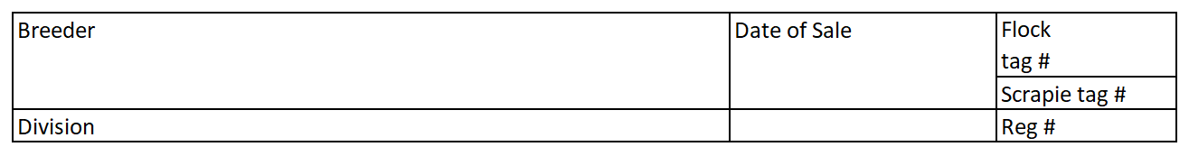

**Points Form**

